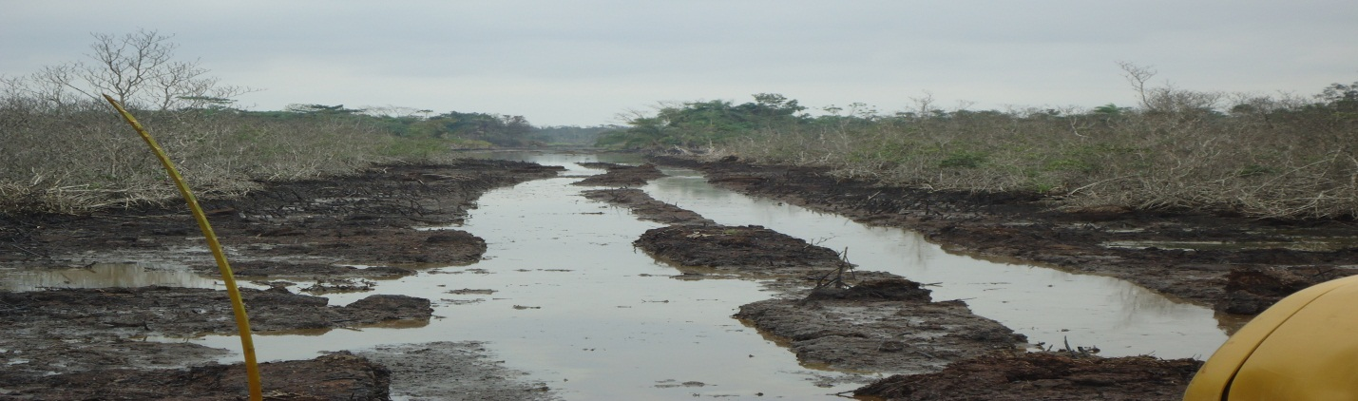Spill point before exposing the line.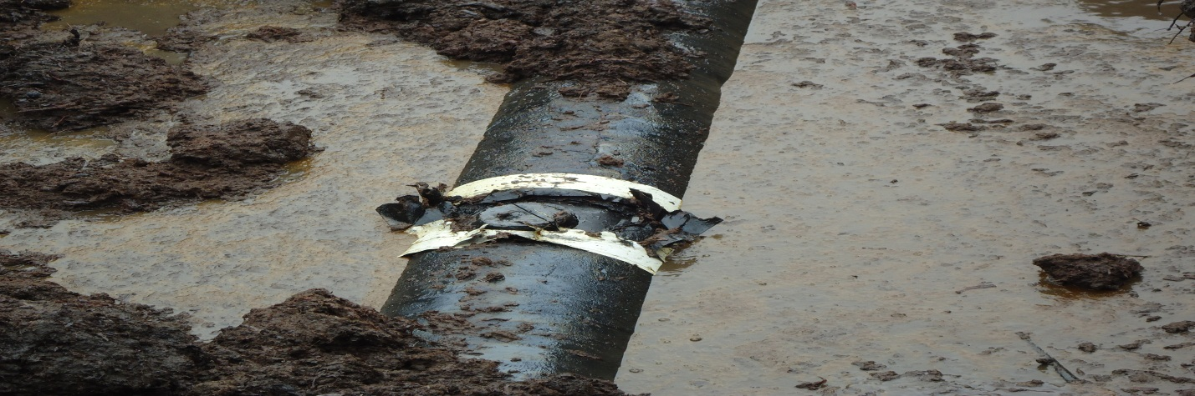
Pix showing cut on previously repaid point (cone).
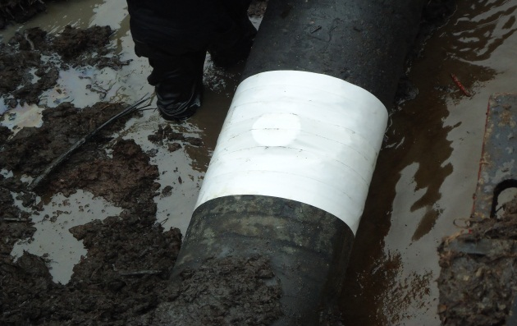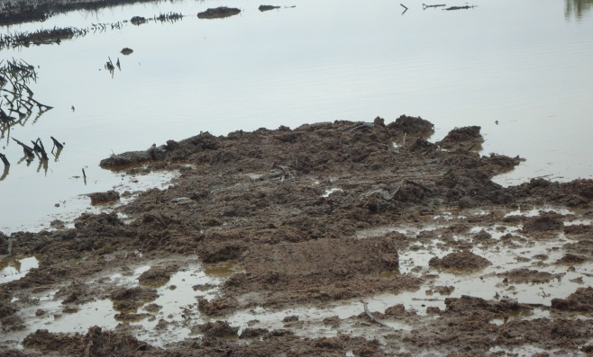
Pix showing the rapping. Point backfilled after repair.

